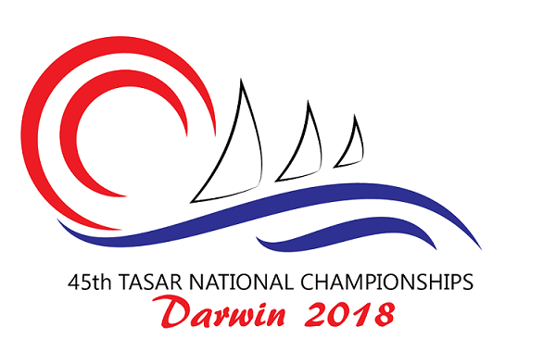
Measurement and Tasar Class Rules
At the 45th Tasar National Championships to be held in Darwin all competitors and their boats will be expected to meet the requirements of the Tasar Class Rules. Competitors, not Regatta Officials or Measurers, are responsible for ensuring their boats and equipment fall within the Class Rules.

As part of the regatta preparation its important that competitors take time out to obtain a copy of the Tasar Class Rules, to ensure their boat complies. In this regard, while all the Class Rules are important, the following key check points will help ensure a hassle free event.

- Hull weight correctors fitted – usually around the thwart support post
- Whisker pole length - 2038mm maximum including end fittings
- Forestay measurement - 4140 mm +/- 20mm
- Hounds to deck measurement - 3720mm minimum
- Mainsheet strop length - 240mm minimum
- Shroud pullback travel - 150mm maximum
- Top of jib to hounds fitting - 115mm maximum (Dacron sails only)
- Bow U bolt to forward track end bolt hole (RCB only) - 2130+/- 5mm
- Centrecase padding - as per class rules
- Topmast stiffener present - as per class rules
- Topmast supported by sleeve located in bottom mast – as per class rules

Prior to the regatta local Measurers and/or Tasar Associations will be available to help competitors with any questions they might have about the class rules.

Competitors will be asked to complete the attached declaration when they register at the regatta.

During the regatta, random measurement checks and inspections will be carried out. A boat selected for inspection shall report to the nominated area upon return to shore and follow the instructions of the Race Committee.

Fiona McManus Stuart Templeton
Organising Committee National Measurer
fmcmanus10@gmail.com stuart@oogywawa.com.au
45th Tasar National Championships
Regatta Measurement Form

This form should be completed and submitted as part of the regatta registration.
Part A - Declaration
Sail Number _______ Hull Colour ___________ Boat name ________________
Skipper _______________________ Crew _________________________
I hereby declare that my boat (sail number)._______ complies with the Tasar Class Rules.
Competitors name: _________________ Signature __________________ Date __________
Part B - Registration
Items to be completed at regatta registration
1) Sails - Royalty tag numbers: Mainsail ________ Jib 1 ________ Jib 2 ________
2) Battens marked _________
3) Foils stamped/signed _________
4) Total crew weight ________kg
5) Hull weight including correctors ________kg
6) Is crew weight ballast fitted? __________
Location? ____________________________
7) Forestay Length - 4140mm +/-20mm _________
8) Hounds to Deck - minimum 3720mm _________
9) Mainsheet Strop - minimum 240mm _________
10) Whisker Pole Length - maximum 2038mm _________
11) Shroud Pullback - Maximum length 150mm _________

Regatta measurement completed by:
Name _____________________ Signature ____________________ Date __________

- It is each competitor’s responsibility to ensure their boat complies with the Tasar Class Rules whilst racing. Please note you may be disqualified if your boat does not comply.
- Refer to Tasar Class Rule C.2.1.c re replacement of equipment during the regatta. Should immediate equipment replacement be necessary to continue racing, written permission from the Race Committee may be sought post race, but prior to the next race.
- Random measurement checks and inspections will be conducted at the discretion of the Race Committee. A boat selected for inspection shall report to the nominated area upon return to shore and prior to unrigging (sails may be dropped only but shall still be attached via their halyards). Skipper and/or crew must remain with the boat at all times whilst checking takes place.

