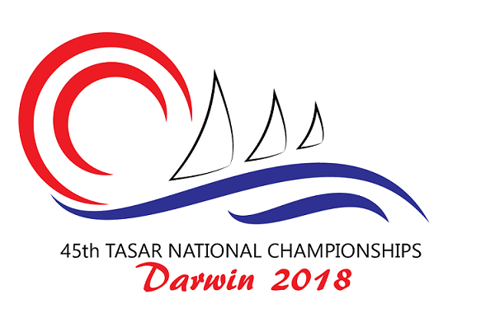
Pre Measurement and Tasar Class Rules
As part of the 45th Tasar Nationals to be held at Darwin Sailing Club the organising committee will be offering competitors the option of pre measurement. Pre measurement will be open from the 1st of June and will close on the 11th July. Completed pre measurement form must be returned to the event measurer by 1700hrs on the 11th of July via email. Please bring your pre measurement form with you to complete your registration at Darwin Sailing Club.

At the 45th Tasar National Championships to be held in Darwin all competitors and their boats will be expected to meet the requirements of the Tasar Class Rules. Competitors, not Regatta Officials or Measurers, are responsible for ensuring their boats and equipment fall within the Class Rules.

During the regatta, random measurement checks and inspections will be carried out. A boat selected for inspection shall report to the nominated area upon return to shore and follow the instructions of the Race Committee.

As part of the regatta preparation its important that competitors take time out to obtain a copy of the Tasar Class Rules, to ensure their boat complies. In this regard, while all the Class Rules are important, the following key check points will help ensure a hassle free event.

Fiona McManus Stuart Templeton
Organising Committee National Measurer
fmcmanus10@gmail.com stuart@oogywawa.com.au
45th Tasar National Championships
Pre - Regatta Measurement Form

This form should be completed and submitted by the 11th July 2018 to the regatta measurer via email to fmcmanus10@gmail.com and cc the national measurer in at stuart@oogywawa.com.au .
Part A - Pre measurement
Sail Number _______ Hull Colour ___________ Boat name ________________
Skipper _______________________ Crew _________________________
I hereby declare that my boat (sail number)._______ complies with the Tasar Class Rules.
Competitors name: _________________ Signature __________________ Date __________
1) Forestay Length - 4140mm +/-20mm _________
2) Hounds to Deck - minimum 3720mm _________
3) Mainsheet Strop - minimum 240mm _________
4) Whisker Pole Length - maximum 2038mm _________
6) Shroud Pullback - Maximum length 150mm _________

Part B - On Site Measurement
Items to be completed at regatta registration
1) Sails - Royalty tag numbers: Mainsail ________ Jib 1 ________ Jib 2 ________
2) Battens marked _________
3) Foils stamped/signed _________
4) Total crew weight ________kg
5) Hull weight including correctors ________kg
6) Is crew weight ballast fitted? __________
Location? ____________________________

Regatta measurement completed by:
Name _____________________ Signature ____________________ Date __________
- It is each competitor’s responsibility to ensure their boat complies with the Tasar Class Rules whilst racing. Please note you may be disqualified if your boat does not comply.
- Refer to Tasar Class Rule C.2.1.c re replacement of equipment during the regatta. Should immediate equipment replacement be necessary to continue racing, written permission from the Race Committee may be sought post race, but prior to the next race.
- Random measurement checks and inspections will be conducted at the discretion of the Race Committee. A boat selected for inspection shall report to the nominated area upon return to shore and prior to unrigging (sails may be dropped only but shall still be attached via their halyards). Skipper and/or crew must remain with the boat at all times whilst checking takes place.

